HARVELELECTRIC ELECTRONIC STORE

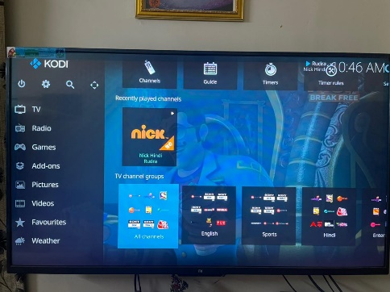

Infinity 40"INCHES FULL HD LED TV & HDMI Wire

Brand: [Infinity](https://www.jumia.com.ng/infinity/)

**Price: $5210**

Was ~~$6000~~ 54%

+ shipping only for V.V.I.P clients.

## **Product details**

Enjoy a greater level of home entertainment realism than ever before. Thanks to a resolution twice as high as standard HD TVs, your Samsung FHD TV delivers a breathtaking viewing experience that takes you beyond the screen into a world of total immersion. When you’ve seen the rich and vivid texture of Full HD images, your favourite TV programs and movies will never be the same again. Discover reality with a full high definition experience.  
Discover a new reality in Full HD  
  
More vibrant colours for better images  
Using an advanced picture quality improvement algorithm, Infinity Wide Colour Enhancer drastically improves the quality of any image and uncovers hidden details. Now see colours as they were meant to be seen with Wide Colour Enhancer.  
More vibrant colours for better images  
Watch movies from your USBWith ConnectShare Movie, simply plug your USB memory drive or HDD into the TV and instantaneously enjoy movies, photos or music. Now, you can experience a wide variety of content in the comfort of your living room on your TV.  
Watch movies from your USB  
*Supported formats include AVI, ASF, MP3, JPEG and others. See manual for a full list of formats supported  
Bringing a full multimedia experience into your living room With High Definition Multimedia Interface (HDMI) inputs, the InfinityTV will transform your living room into a multimedia entertainment centre. HDMI provides high-speed transmission of high definition digital data from multiple devices straight into your TV.  
Bringing a full multimedia experience into your living room

## **Specifications**

## **KEY FEATURES**

* 40" DIGITAL LED TV
* Free wall hanger and HDMI wire
* Antenna Input
* 2 AV
* 2 HDMI
* 2 USB (DivX)
* Resolution 1366x768
* Audio Output 10W
* Speaker System (ch) 2.0

## **WHAT’S IN THE BOX**

40'' infinity tv manual, free wall hanger and HDMI wire.

## **SPECIFICATIONS**

* **SKU**: IN538EA069JP3NAFAMZ
* **Product Line**: penny price
* **Model**: INF-40
* **Weight (kg)**: 12
* **Certifications**: Eco Friendly
* **Color**: Black
* **Main Material**: LED Screen
* **Shop Type**: Harvel Electric Store